The Family Engagement Tool from Buena Vista Elementary School provides a secure and convenient means for teachers to communicate with students and their families.

Family Engagement Tool

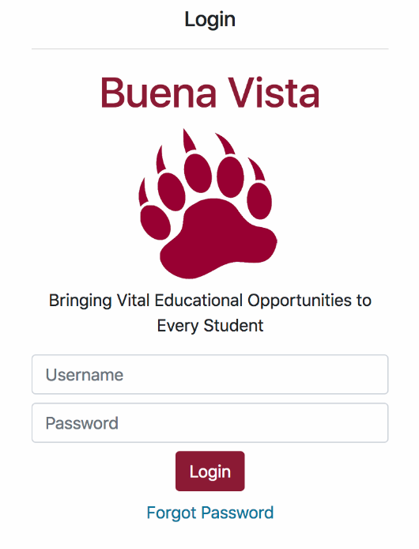The Family Engagement Tool provides easy access to class schedules, secure messaging, and enables direct communication between schools and students about events, schedule changes, and other important information. Learn how to create an account, send messages, and view or modify class schedules using the mobile app.

# The Login Screen

Using the mobile app is simple! The first time you use the app, you should begin by creating an account. To create an account, tap Setup New Account to get started.

Once you have created an account, enter your username and password on the Login Screen. Tap Login to continue.

## Forgotten Passwords

If you have forgotten your password, tap Forgot Password to reset it. The Forgot Password screen asks you to confirm your email address and then sends a link to that email address which you need to click to create a temporary password. Be sure that your email address is correct and then click Continue.

Check your email for a message from _____@__.com and then click the link in the message. You will be asked to choose a new password.

## Account Creation

New Accounts require Administrator approval. Once approved for a new Account, an Administrator will send you a text message containing a special link to create an Account. Click this link to go to the New Account screen. Choose a username and password and be sure to pick something you won’

## Need Help?

If you need help, contact an Administrator or the individual identified at the bottom of the Login Screen.

# Using the App

The home screen displays a series of tiles to navigate the app.

* **Messages** provides a place for parents and teachers to communicate with each other.
* **Calendar** allows teachers and school administrators to post announcements and important dates related to events and assignments.
* **My Account** is where you can change your phone number, update your password, and other key details about your account.

# C:\Users\dcsmith\Desktop\BV-app-screenshots2\Screen Shot 2018-04-13 at 11.45.30 AM.pngMessages

The messaging section of the app sends push notifications to alert students’ families about key information and allows for two-way communication between families and teachers. Teachers and other school staff can send messages to other teachers, and notifications to specific student(s) or to an entire class.

## Using Messages

Depending on your role, certain features may or may not be available for you to use, and some may look slightly different from what you see here.

### Teachers

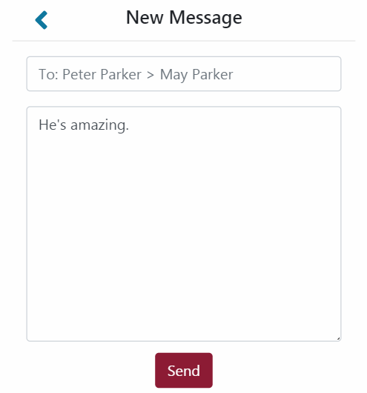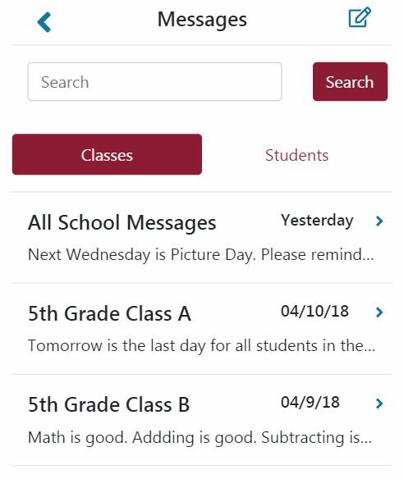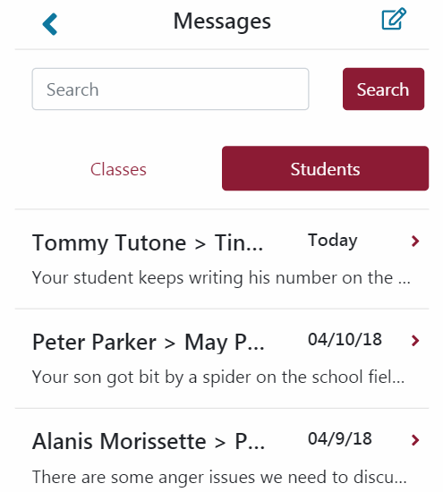

Teachers can use the app to send direct messages to parents of their students or to an entire class, depending on the mode selected. Tap Classes to toggle class messaging mode, or tap Parents to toggle parent messaging mode. In either mode, tap the New Message () button to write a new message, or tap on an existing message thread to respond to it. Teacher messages and replies from parents display in the order sent, and message threads display in descending order of most recent activity.

When writing a new message, tap the To: field to select from a list of available recipients. Then, enter your message in the field below it and click Send to submit your message.

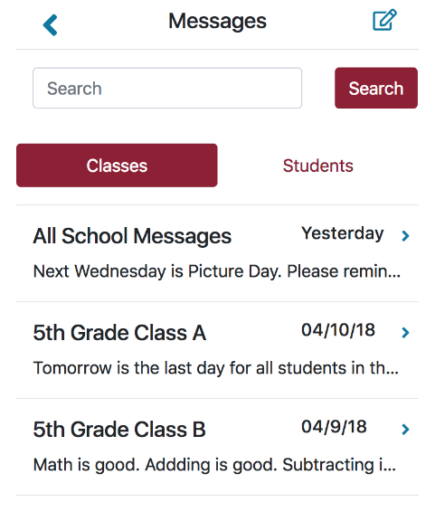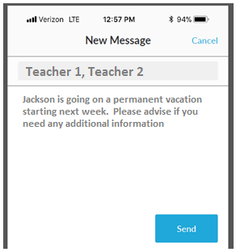

### Parents

Parents can use the app to communicate with teachers of their students. Parents can use the app to send and respond to direct messages from teachers, or to view messages sent by teachers to an entire class, depending on the mode selected. Tap Classes to toggle class messaging mode, or tap Parent/Teacher to toggle teacher messaging mode. In either mode, tap the New Message () button to write a new message, or tap on an existing message thread to respond to it. Your messages to and any replies from teachers display in the order sent, and message threads display in descending order according to most recent activity.

When writing a new message, tap the To: field to select from a list of your student’s teachers. Then enter your message in the field below it and click Send to submit your message. If multiple teachers are selected, a new message thread will be created for each teacher.

# Administrators

Administrators have an expanded view and set of capabilities related to the management and operation of the app. In addition to the Calendar and Messages capabilities available to other users, Administrators have an additional Admin section that allows them to perform administrative functions. Administrators can post messages to the entire school and are responsible for creating accounts, configuring classes, associating teachers and students with those classes, and other maintenance and administrative functions.

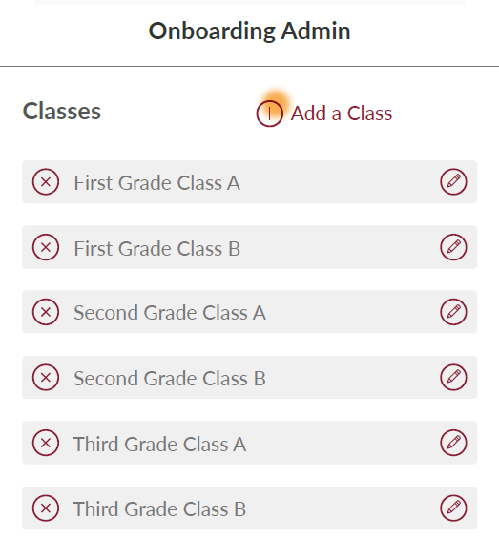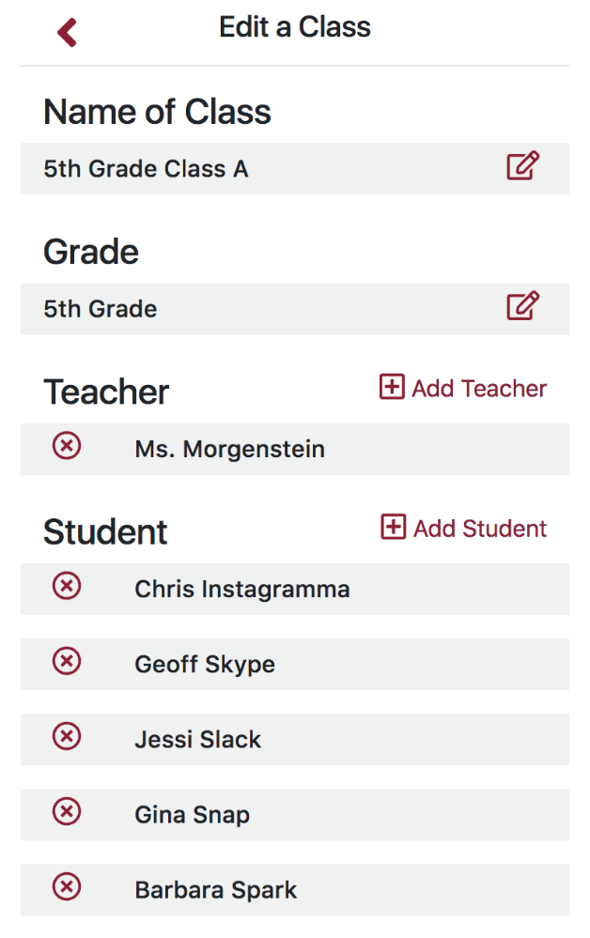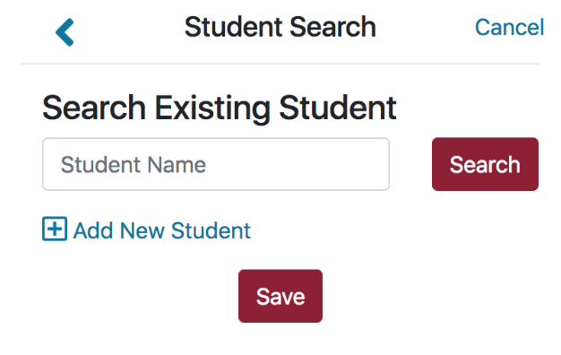

## Creating New Accounts

Use the administrator dialog to create new accounts.

## Classes

To enable students and teachers to communicate with each other, start by configuring the class schedule. Start by, tapping Add a Class, then give it a Name, assign it to a Grade, and press Save. The selected Grade determines which students and teachers are able to see that class.

#### Configuring and Editing Classes

Once you build a class, you can then associate Teachers and Students with it by using the  and buttons. These associations determine which students and teachers can communicate with each other. Class details and student and teacher associations can be edited or deleted at any time by tapping the Edit () or Delete () buttons.

#### Adding Teachers and Students

While associating students and teachers to a class, you have the option to create new students or teachers without leaving this section of the app by tapping  or .

can use the app to send direct messages to parents of their students or to an entire class, depending on the mode selected. Tap Classes to toggle class messaging mode, or tap Parents to toggle parent messaging mode. In either mode, tap the New Message () button to write a new message, or tap on an existing message thread to respond to it. Teacher messages and replies from parents display in the order sent, and message threads display in descending order of most recent activity.

When writing a new message, tap the To: field to select from a list of possible recipients. Then, enter your message in the field below it and click Send to submit your message.

* Administrator should be able to send mass communications to all/any class (this is not mocked up)
* Users and date and time stamps should be saved by message

User (parent) should select the student (child). If only one then it should default to one student.

* 1. If messages already exist the user (parent) will see list of all messages associated to all classes of their child

* + 1. Class tab is a quick view to class messages. No replies can be made to class.

Below:

* + 1. Start a new message by clicking the pencil icon

Teacher selection process missing from mockups

Teachers list – if one teacher then prepopulate, if many allow selection.

* 1. User (parent) may select Parent/Teacher tab to view all communication specific to their child.
     1. If messages already exist the user (parent) will see list of all messages associated to their child

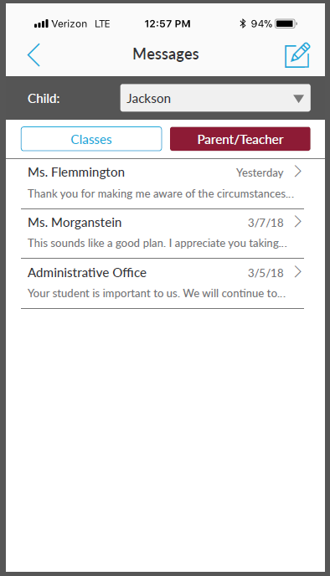

* + 1. From here the parent can click into existing thread to message or start a new message by clicking the pencil icon
       1. Teacher selection process missing from mockups

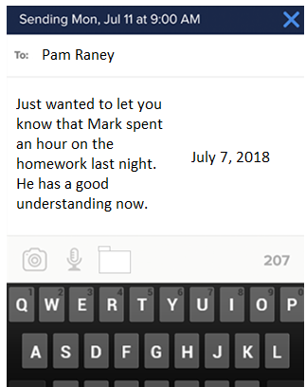

***Teacher view***

1. User (teacher) should select the Class or Parent view
   1. When class view is selected display all classes teacher is associated with

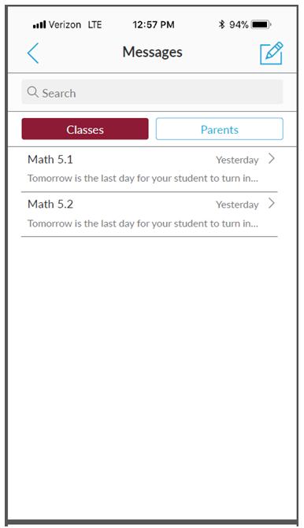

* 1. Allow the teacher to communicate for one or many class(es) for mass communication to be posted on class and students notes/threads
     1. Class selection process missing from mockups

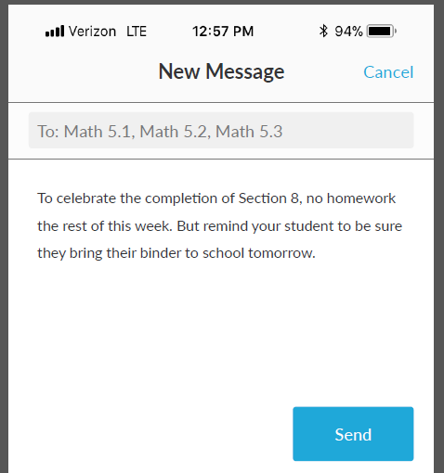

* 1. Conversations (messages) should be viewable to user (teacher) by Parent and class view
     + 1. Sorted by postdate descending order

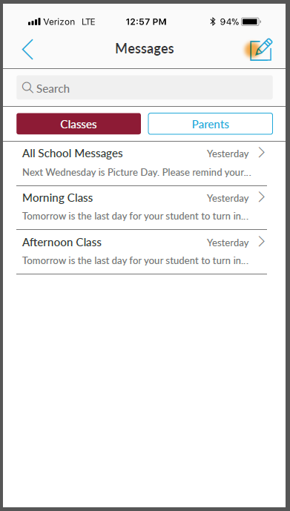

* 1. Allow the teacher to select a parent of student from the class for single communication on student

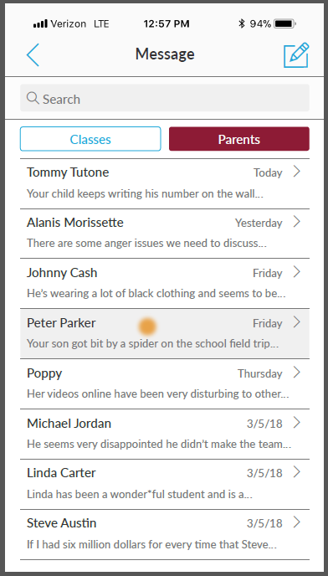

* + 1. User may select preexisting note to continue messaging or begin a new message.